System Architecture
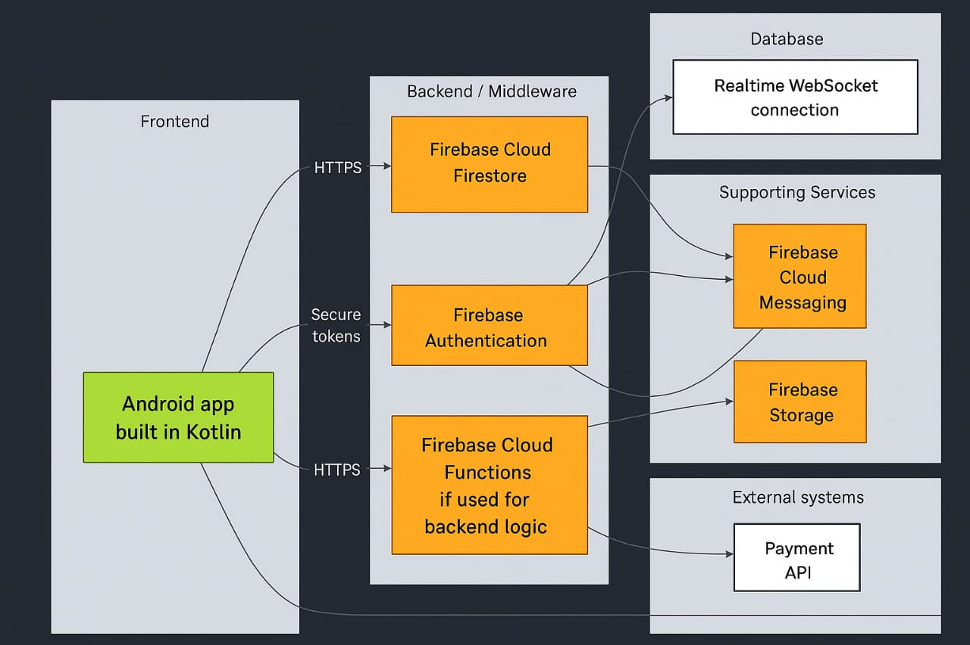
Figure 5: System Architecture (Anthropic, 2025)
System Architecture Overview
This diagram represents the system architecture of an Android application built in Kotlin, integrated with Firebase services to manage backend functionality, authentication, and cloud operations.
1. Frontend Layer
The frontend is the Android app built in Kotlin.
It serves as the user interface, allowing users to interact with the system through screens and forms.
The app communicates securely with Firebase services using HTTPS and secure tokens for data transmission and authentication.
2. Backend / Middleware Layer
This layer manages all the business logic and communication with Firebase. It includes:
Firebase Cloud Firestore:
A NoSQL cloud database used to store and sync app data in real time. It replaces the Realtime Database and offers better scalability, structure, and querying capabilities.
Firebase Authentication:
Handles user sign-in and access control using email/password, Google, or other authentication methods. It ensures that only authorized users access certain app features.
Firebase Cloud Functions:
Used to execute backend logic on Firebase’s cloud infrastructure.
For example, it can trigger automated tasks such as sending notifications or processing payments whenever specific events occur.
3. Database Layer
Firestore connects to a Realtime WebSocket connection to keep data synchronized between the app and the server.
This ensures that changes made in the database reflect instantly across all connected users.
4. Supporting Services
These are Firebase services that enhance functionality:
Firebase Cloud Messaging (FCM):
Enables push notifications to users (e.g., event reminders, alerts).
Firebase Storage:
Stores and manages large files such as images, documents, or media uploads from the app.
5. External Systems
The architecture also integrates with third-party systems for extended functionality:
Payment API: For handling secure online transactions or in-app purchases.
Analytics / Crashlytics: For monitoring user behavior, tracking app performance, and detecting crashes or errors.
6. Security
All communication between the app and Firebase services occurs over HTTPS for encryption.
Secure tokens ensure that only authenticated users can access data and functions. (OpenAI, 2025)

Referencing
Anthropic. 2025. Claude Code (Version 1.0). [Large language model and code assistant]. Available at: https://www.anthropic.com/claude-code [Accessed: 13 October 2025].
Mthenjana, M., 2025. ERD diagram. [Personal drawing]. Durban North: Unpublished.
OpenAI. 2025. Chat-GPT (Version 3.5). [Large language model]. Available at: https://chat.openai.com/ [Accessed: 13 October 2025].

